1. Create the database in your (localdb)\MSSQLLocalDB based on the Database Code.docx file
2. Go to NewStudentManagementApp2WebAPI -> Properties -> Web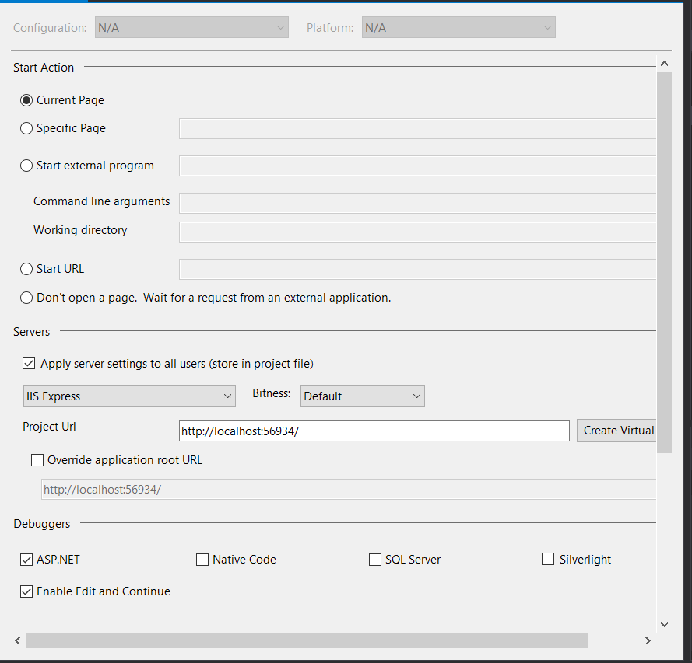
3. Copy the project url and click the Create Virtual Directory button
4. Change the url constant in the classes Model>StudentManagementDBAcess.cs and Persistency>StudentWebAPIAsync.cs
5. View the NewStudentManagementApp2WebAPI project in your browser 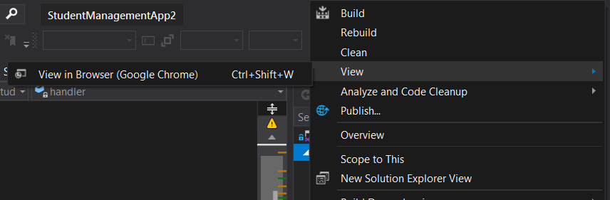
6. The program should now work correctly when run